WEEK 4 INTERNSHIP TASK
Advanced Model Evaluation, Tuning, and Reporting
Project: Telco Customer Churn
Submitted by: K. Avinash
Program: BTech Computer Science and Engineering
Domain: Data Analytics and Machine Learning
Week: 4
Internship Name: - Virtual Data Science Apprentice Intern

1.Executive Summary
Customer churn is an important business problem for telecommunications companies because losing existing customers can negatively affect revenue and increase the cost of acquiring new customers. The objective of this project is to develop a machine learning classification model capable of predicting whether a customer is likely to churn.
The Telco Customer Churn dataset was used throughout the internship project. A Decision Tree classification model was developed as the baseline model during the previous week. In Week 4, the baseline model was evaluated using advanced evaluation techniques and subsequently optimized using hyperparameter tuning.
Five-fold Stratified Cross-Validation was used to evaluate model stability. Grid Search was then applied to optimize important Decision Tree hyperparameters, including maximum tree depth, minimum samples required for splitting and leaf creation, maximum features, criterion, and class weighting. A total of 50 hyperparameter combinations were evaluated using five-fold cross-validation, resulting in 250 model fits.
The best configuration achieved a cross-validation F1-score of approximately 0.6166. The final tuned model was then evaluated on the same held-out test set as the baseline model.
The baseline Decision Tree achieved an accuracy of 75.16%, F1-score of 61.96%, and ROC-AUC of 83.53%. The tuned Decision Tree achieved an accuracy of 71.97%, F1-score of 59.40%, and ROC-AUC of 80.16%. However, recall improved slightly from 76.20% to 77.27%.
Therefore, hyperparameter tuning did not improve the overall performance of the model, but it increased the model's ability to identify customers who actually churned. The baseline model was selected as the preferred model for overall predictive performance, while the tuned model could be considered when minimizing missed churn customers is the primary objective.
2. Introduction
Customer retention is an important factor in the telecommunications industry. Customers may discontinue their services because of pricing, service quality, contract conditions, competition, or dissatisfaction with the services provided.
Machine learning can help organizations identify customers who have a higher probability of leaving. By identifying potential churners in advance, companies can take appropriate actions such as offering personalized plans, discounts, improved support, or other retention strategies.
This project focuses on developing and evaluating a machine learning model for predicting customer churn using the Telco Customer Churn dataset.
The Week 4 task extends the previous modeling work by focusing on:
- Advanced model evaluation
- Cross-validation
- Hyperparameter tuning
- Performance comparison
- Confusion matrix analysis
- ROC and Precision-Recall analysis
- Business interpretation
- Model limitations
- Recommendations for future improvements
3. Problem Statement
The problem addressed in this project is:
To develop a machine learning classification model that can predict whether a telecom customer is likely to churn based on customer demographic information, services, contract details, and billing characteristics.
The target variable is Churn, which contains two classes:
- 0 – No Churn
- 1 – Churn
The problem is therefore treated as a binary classification problem.
4. Objectives
The major objectives of this project are:
- To evaluate the previously developed baseline Decision Tree model using multiple performance metrics.
- To apply five-fold Stratified Cross-Validation.
- To analyze Accuracy, Precision, Recall, F1-score, and ROC-AUC.
- To perform hyperparameter tuning using Grid Search.
- To identify the best combination of Decision Tree hyperparameters.
- To compare the tuned model with the baseline model.
- To analyze confusion matrices and classification errors.
- To evaluate the models using ROC and Precision-Recall curves.
- To identify the trade-offs introduced by hyperparameter tuning.
- To provide business-oriented recommendations and suggestions for future improvement.
5. Dataset Description
The Telco Customer Churn dataset contains information about customers of a telecommunications service provider.
The dataset contains:
- 7,043 customer records
- 21 columns
The dataset includes customer demographic information, subscribed services, contract details, payment information, and churn status.
Important Features
Feature | Description
gender | Customer gender
SeniorCitizen | Indicates whether the customer is a senior citizen
Partner | Whether the customer has a partner
Dependents | Whether the customer has dependents
tenure | Number of months the customer has stayed
PhoneService | Whether phone service is subscribed
MultipleLines | Multiple phone lines subscription
InternetService | Type of internet service
OnlineSecurity | Online security subscription
OnlineBackup | Online backup subscription
DeviceProtection | Device protection subscription
TechSupport | Technical support subscription
StreamingTV | Streaming TV subscription
StreamingMovies | Streaming movie subscription
Contract | Customer contract type
PaperlessBilling | Paperless billing status
PaymentMethod | Payment method
MonthlyCharges | Monthly customer charges
TotalCharges | Total amount charged
Churn | Target variable

6. Data Preparation
Before model development, the dataset was prepared for machine learning.
The preparation process included:
- Loading the dataset using Pandas.
- Inspecting the dataset structure.
- Checking missing values.
- Checking duplicate records.
- Converting numerical fields into appropriate numerical formats.
- Separating independent features from the target variable.
- Encoding categorical variables.
- Splitting the dataset into training and testing sets.
- Maintaining the class distribution using stratified sampling.
The final modeling data used a training set containing 5,634 records and a test set containing 1,409 records.
The test set contained:
- 1,035 No Churn customers
- 374 Churn customers
A stratified split was used so that the proportion of churn and non-churn customers remained reasonably consistent between the training and testing sets.
7. Baseline Decision Tree Model
A Decision Tree classifier was used as the baseline model.
The baseline model provides a reference point against which the tuned model can be evaluated.
The baseline model was evaluated using:
- Accuracy
- Precision
- Recall
- F1-score
- ROC-AUC
Baseline Performance
Metric | Score
Accuracy | 0.7516
Precision | 0.5220
Recall | 0.7620
F1-score | 0.6196
ROC-AUC | 0.8353

The baseline model achieved an overall accuracy of approximately 75.16%. Its recall of 76.20% indicates that it successfully identified a substantial proportion of customers who actually churned.
However, its precision of 52.20% indicates that a considerable number of customers predicted as churners were actually non-churners.
8. Advanced Model Evaluation
Advanced evaluation was performed because accuracy alone does not provide a complete picture of a classification model's performance, particularly when the target classes are imbalanced.
The following metrics were considered.
Accuracy
Accuracy represents the proportion of all predictions that were correct.
Precision
Precision represents the proportion of customers predicted as churners who actually churned.
Recall
Recall represents the proportion of actual churners successfully identified by the model.
F1-score
F1-score is the harmonic mean of precision and recall.

ROC-AUC
ROC-AUC measures how effectively the model distinguishes between the positive and negative classes across different classification thresholds.
9. Cross-Validation
Five-fold Stratified Cross-Validation was used to obtain a more reliable estimate of model performance.
In five-fold cross-validation, the training data is divided into five subsets. The model is trained using four subsets and validated using the remaining subset. This process is repeated five times so that every subset is used as the validation set once.
Stratification was used to maintain the class distribution of the churn target across the folds.
Baseline Cross-Validation Results
Metric | Mean | Standard Deviation
Accuracy | 0.7476 | 0.0147
Precision | 0.5173 | 0.0198
Recall | 0.7732 | 0.0300
F1-score | 0.6193 | 0.0114
ROC-AUC | 0.8276 | 0.0131
The relatively small standard deviations indicate that the baseline model showed reasonably stable performance across the five folds.
10. Hyperparameter Tuning
Hyperparameter tuning was performed to determine whether the Decision Tree's performance could be improved by finding a better configuration of its parameters.
Tuning Strategy
Grid Search was selected because it systematically evaluates predefined combinations of hyperparameters.
The tuning process evaluated:
- criterion
- max_depth
- max_features
- min_samples_split
- min_samples_leaf
- class_weight
A total of 50 parameter combinations were evaluated using 5-fold cross-validation.
Therefore:
50 combinations × 5 folds = 250 model fits
The primary optimization metric was F1-score because it provides a balance between Precision and Recall.
Code Used for Tuning
grid_search = GridSearchCV(
estimator=pipeline,
param_grid=param_grid,
scoring="f1",
cv=5,
n_jobs=-1,
verbose=1
)

grid_search.fit(X_train, y_train)
11. Best Hyperparameters
The Grid Search process identified the following configuration as the best combination:
Hyperparameter | Selected Value
Criterion | Gini
Maximum Depth | 4
Maximum Features | log2
Minimum Samples Split | 40
Minimum Samples Leaf | 15
Class Weight | Balanced

Best Cross-Validation Result
Best F1-score = 0.6166
The selected parameters create a relatively constrained Decision Tree. The maximum depth of four limits the complexity of the tree, while the minimum sample requirements prevent the tree from creating overly small branches.
The balanced class-weight setting gives additional importance to the minority churn class.

12. Tuned Decision Tree Model
The best configuration identified through Grid Search was used to create the final tuned Decision Tree.
The tuned model was evaluated on the same 1,409-record test set used for evaluating the baseline model.
Tuned Model Performance
Metric | Score
Accuracy | 0.7197
Precision | 0.4825
Recall | 0.7727
F1-score | 0.5940
ROC-AUC | 0.8016
The tuned model achieved a recall of 77.27%, which is slightly higher than the baseline recall of 76.20%.
However, its accuracy, precision, F1-score, and ROC-AUC were lower than those of the baseline model.
13. Baseline vs Tuned Performance
The final comparison is shown below.
Metric | Baseline | Tuned | Change
Accuracy | 0.7516 | 0.7197 | -0.0319
Precision | 0.5220 | 0.4825 | -0.0395
Recall | 0.7620 | 0.7727 | +0.0107
F1-score | 0.6196 | 0.5940 | -0.0255
ROC-AUC | 0.8353 | 0.8016 | -0.0338

Interpretation
The results demonstrate that hyperparameter tuning did not improve the overall performance of the Decision Tree.
The most notable improvement was Recall:
76.20% → 77.27%
This means that the tuned model identified a slightly greater proportion of actual churn customers.
However, the improvement in recall came with reductions in Precision, Accuracy, F1-score, and ROC-AUC.

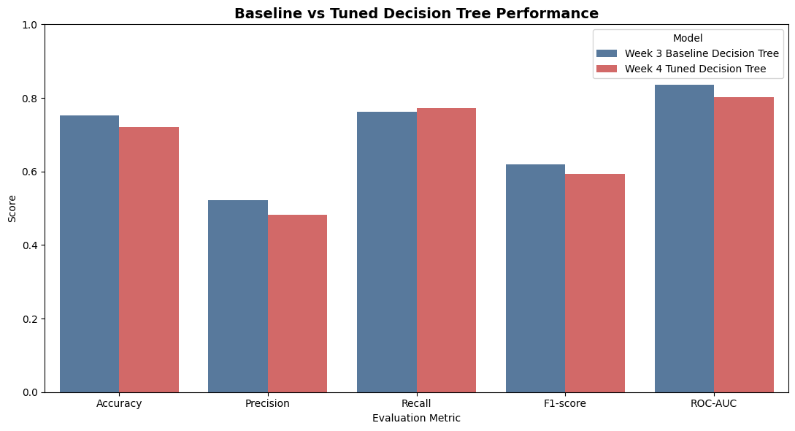
Figure 1: Baseline vs Tuned Decision Tree Performance
14. Confusion Matrix Analysis
The confusion matrix provides a detailed view of the correct and incorrect predictions.
Baseline Decision Tree
[[774 261]
[ 89 285]]
 | Predicted No Churn | Predicted Churn
Actual No Churn | 774 | 261
Actual Churn | 89 | 285

The baseline correctly identified:
- 774 non-churn customers
- 285 churn customers
It incorrectly classified:
- 261 non-churn customers as churn
- 89 churn customers as non-churn
Tuned Decision Tree
[[725 310]
[ 85 289]]

 | Predicted No Churn | Predicted Churn
Actual No Churn | 725 | 310
Actual Churn | 85 | 289

The tuned model correctly identified:
- 725 non-churn customers
- 289 churn customers
It incorrectly classified:
- 310 non-churn customers as churn
- 85 churn customers as non-churn
Interpretation
- The tuned model detected four more actual churners than the baseline model:
- 289 − 285 = 4 additional churners detected
- At the same time, false positives increased:
- 310 − 261 = 49 additional false positives
- This explains the increase in recall and the decrease in precision.
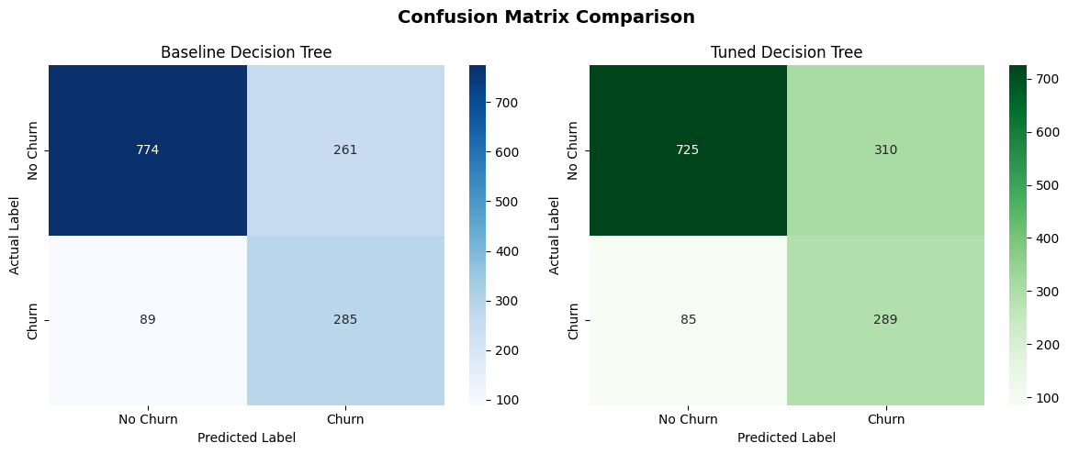
Figure 2: Confusion Matrix Comparison of Baseline and Tuned Decision Trees
15. ROC Curve Analysis
The Receiver Operating Characteristic (ROC) curve compares the True Positive Rate with the False Positive Rate at different classification thresholds.
The Area Under the Curve (AUC) summarizes the model's ability to distinguish between churn and non-churn customers.
Results
Model | ROC-AUC
Baseline | 0.8353
Tuned | 0.8016

The baseline model achieved a higher ROC-AUC than the tuned model.
This indicates that the baseline model has stronger overall discrimination between churn and non-churn customers.
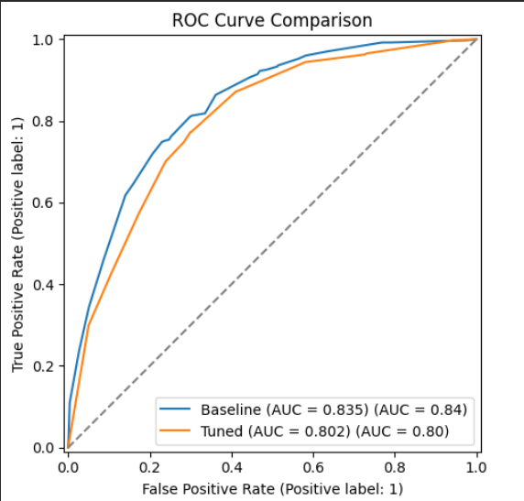
Figure 3: ROC Curve Comparison
The ROC curve demonstrates that both models perform substantially better than random classification, but the baseline model maintains the stronger overall performance.
16. Precision-Recall Curve Analysis
The Precision-Recall curve is particularly useful when dealing with an imbalanced classification problem because it focuses on the positive class.
In this project, the positive class is Churn.
Average Precision
Model | Average Precision
Baseline | 0.626
Tuned | 0.547
The baseline model achieved a higher Average Precision than the tuned model.
This indicates that the baseline model generally provides a better precision-recall trade-off across classification thresholds.
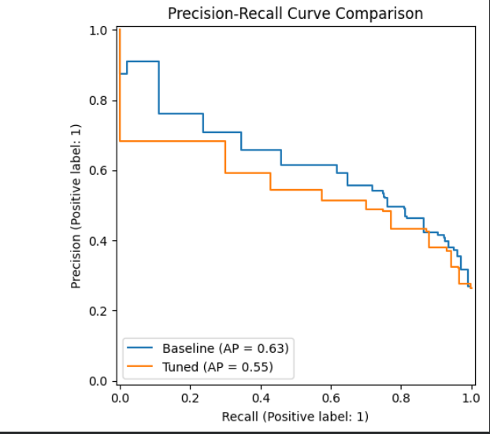
Figure 4: Precision-Recall Curve Comparison
17. Tuned Model Cross-Validation
After identifying the best hyperparameters, the tuned model was evaluated using five-fold Stratified Cross-Validation.
Tuned Cross-Validation Results
Metric | Mean | Standard Deviation
Accuracy | 0.7364 | 0.0133
Precision | 0.5028 | 0.0172
Recall | 0.7987 | 0.0298
F1-score | 0.6166 | 0.0136
ROC-AUC | 0.8134 | 0.0094
The tuned model achieved a mean recall of approximately 79.87% across the five validation folds.
The standard deviations are relatively small, suggesting that the model's performance was reasonably stable across different subsets of the training data.
An important observation is that the cross-validation F1-score of 0.6166 matches the best F1-score identified during Grid Search. This confirms that F1-score was successfully used as the optimization criterion.
18. Business Interpretation
The choice between the baseline and tuned models should depend on the business objective.
For a telecom company, failing to identify a customer who is about to churn can result in lost revenue. Therefore, Recall can be particularly important.
The tuned model achieved:
77.27% Recall
compared with:
76.20% Recall for the baseline
This means the tuned model identifies slightly more actual churners.
However, this improvement comes with a cost.
The tuned model produced:
310 false positives
compared with:
261 false positives for the baseline
Therefore, the company may end up targeting more customers who were not actually going to churn.
For example, if a retention campaign involves discounts, phone calls, or special offers, these additional false positives could increase operational and financial costs.
Therefore:
If the priority is:
Detecting as many churners as possible → Tuned model
Overall predictive performance and fewer false positives → Baseline model

19. Key Findings
The major findings from the Week 4 analysis are:
1. Hyperparameter tuning did not improve overall performance
The tuned model had lower Accuracy, Precision, F1-score, and ROC-AUC than the baseline.
2. Recall improved slightly
Recall increased from:
76.20% → 77.27%
This means the tuned model detected slightly more actual churn customers.
3. False positives increased
False positives increased from:
261 → 310
This contributed to the decrease in precision.
4. Baseline had better overall discrimination
The baseline ROC-AUC was:
0.8353
while the tuned model achieved:
0.8016
5. Baseline had a better Precision-Recall trade-off
Average Precision decreased from:
0.626 → 0.547
after tuning.
6. Cross-validation demonstrated reasonable stability
Both models showed relatively small standard deviations across the five folds.
7. Tuning demonstrates the importance of business objectives
The best model is not necessarily the model with the highest value for every metric. Different business objectives may require different trade-offs between false positives and false negatives.

20. Limitations
Although the project produced useful results, several limitations should be considered.
20.1 Dataset limitation
The model was developed using a single Telco Customer Churn dataset. Therefore, the results may not generalize to other telecom companies or customer populations.
20.2 Class imbalance
The churn class represents a smaller portion of the dataset than the non-churn class. This can affect model training and evaluation.
20.3 Decision Tree limitations
A single Decision Tree may not capture all complex relationships present in customer behavior.
20.4 Limited tuning search space
Grid Search evaluates only the parameter combinations included in the predefined search space. Better configurations may exist outside that search space.
20.5 Static customer information
The dataset represents customer information at a particular point in time. Customer behavior can change over time.
20.6 No external validation
The model was evaluated using data originating from the same dataset. Testing on an independent dataset would provide stronger evidence of generalization.

21. Recommendations and Future Work
Several improvements could be explored in future versions of the project.
21.1 Evaluate ensemble models
Models such as:
- Random Forest
- Gradient Boosting
- XGBoost
- LightGBM
could be compared with the Decision Tree.
Ensemble models can often provide better predictive performance by combining multiple decision-making structures.
21.2 Optimize the classification threshold
The default classification threshold of 0.5 may not be optimal for the business problem.
The threshold could be adjusted depending on whether the business wants to prioritize:
- Higher recall
- Higher precision
- Lower false-negative cost
- Lower false-positive cost
21.3 Cost-sensitive learning
Different costs can be assigned to false positives and false negatives.
For example, if losing a customer is significantly more expensive than contacting a non-churning customer, false negatives could be given a higher cost.
21.4 Model explainability
Feature importance or SHAP analysis could be used to determine which factors contribute most strongly to churn predictions.
This could help business teams understand why a customer is predicted to churn.
21.5 External validation
The final model should ideally be tested on new customer data collected at a later period or from another customer population.
21.6 Model monitoring
If deployed in a real-world environment, model performance should be monitored regularly because customer behavior, pricing, services, and market conditions can change.

22. Conclusion
This Week 4 task focused on advanced evaluation, hyperparameter tuning, and detailed analysis of a Decision Tree model for customer churn prediction.
The baseline Decision Tree achieved an accuracy of 75.16%, F1-score of 61.96%, and ROC-AUC of 83.53%. Hyperparameter tuning was performed using Grid Search with five-fold cross-validation, evaluating 50 parameter combinations and 250 total model fits.
The best configuration used a Gini criterion, maximum depth of four, log2 maximum features, minimum samples split of 40, minimum samples leaf of 15, and balanced class weights. The best cross-validation F1-score was 0.6166.
On the final test set, the tuned model achieved an accuracy of 71.97%, precision of 48.25%, recall of 77.27%, F1-score of 59.40%, and ROC-AUC of 80.16%.
Although tuning slightly improved recall, the baseline model performed better in terms of accuracy, precision, F1-score, ROC-AUC, and Average Precision.
Therefore, the baseline Decision Tree is selected as the preferred model for overall predictive performance.
However, the tuned model demonstrates an important alternative. Its slightly higher recall means that it can be considered when the business places greater importance on identifying as many potential churn customers as possible, even if this results in more false-positive predictions.
Overall, this project demonstrates that hyperparameter tuning does not necessarily improve every evaluation metric. Effective model selection requires consideration of model performance, class imbalance, prediction errors, and the specific business objective.

